USING DDL STATEMENTS TO CREATE AND MANAGE TABLES
1.Create table dept1 as below with following columns:DEPTNO INTEGER PK, DANME VARCHAR2(30) NOT NULL,LOC VARCHAR2(30) NOT NULL
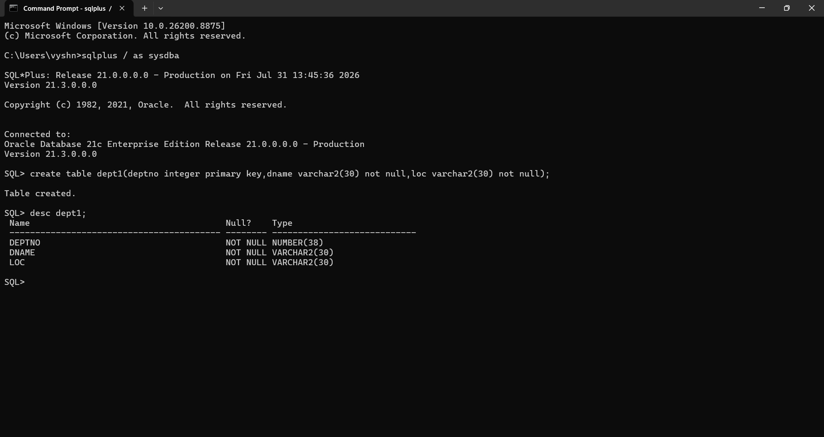
2.Create table emp1 with the following columns EMPNO INTEGER PK, ENAME VARCHAR2(20) NOT NULL,SAL NUMBER(10,2) check(sal>500),mgr number FK(EMPNO),DEPTNO INTEGER FK(DEPTNO)
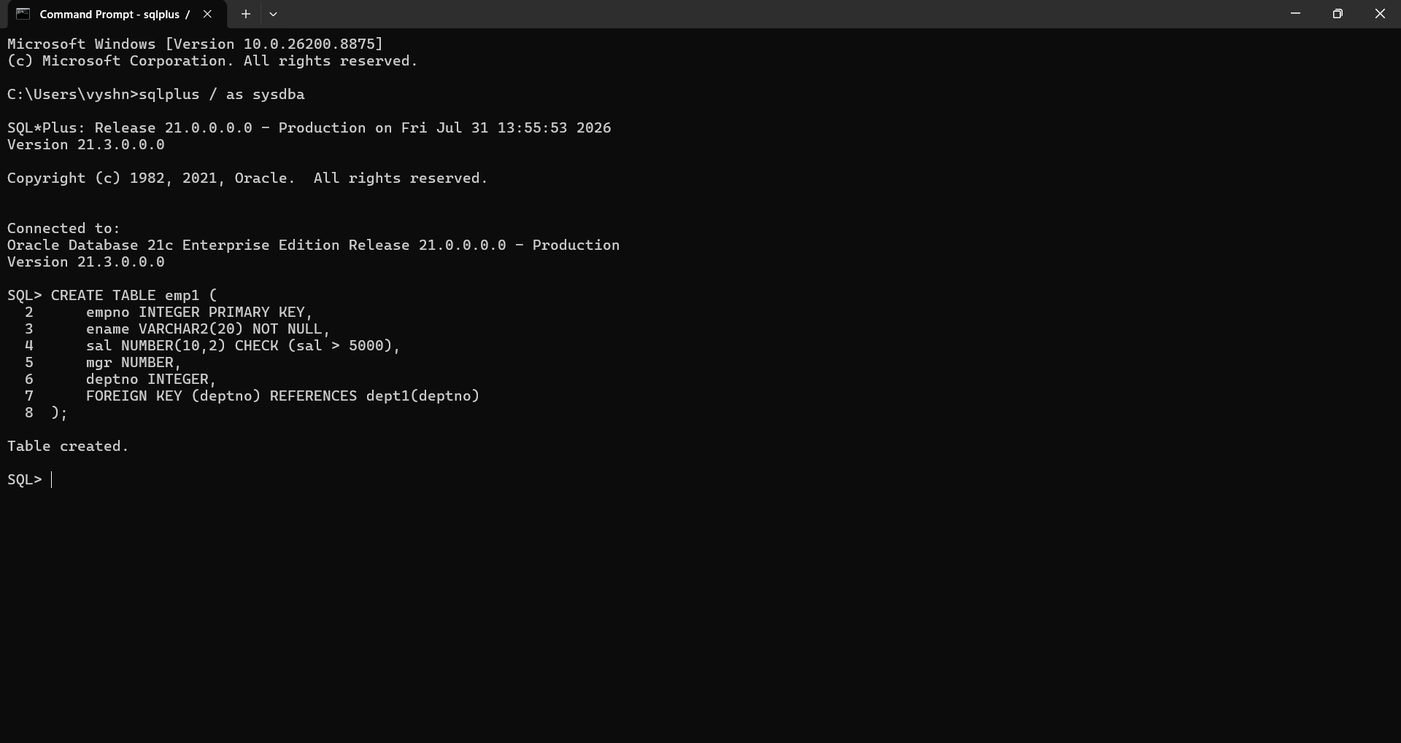

3.Createtables Dept11,Emp11 from Dept1,Emp1.
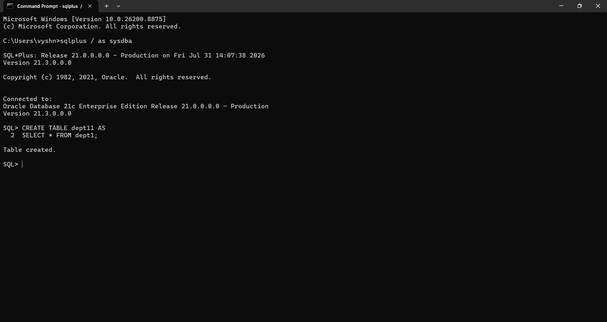
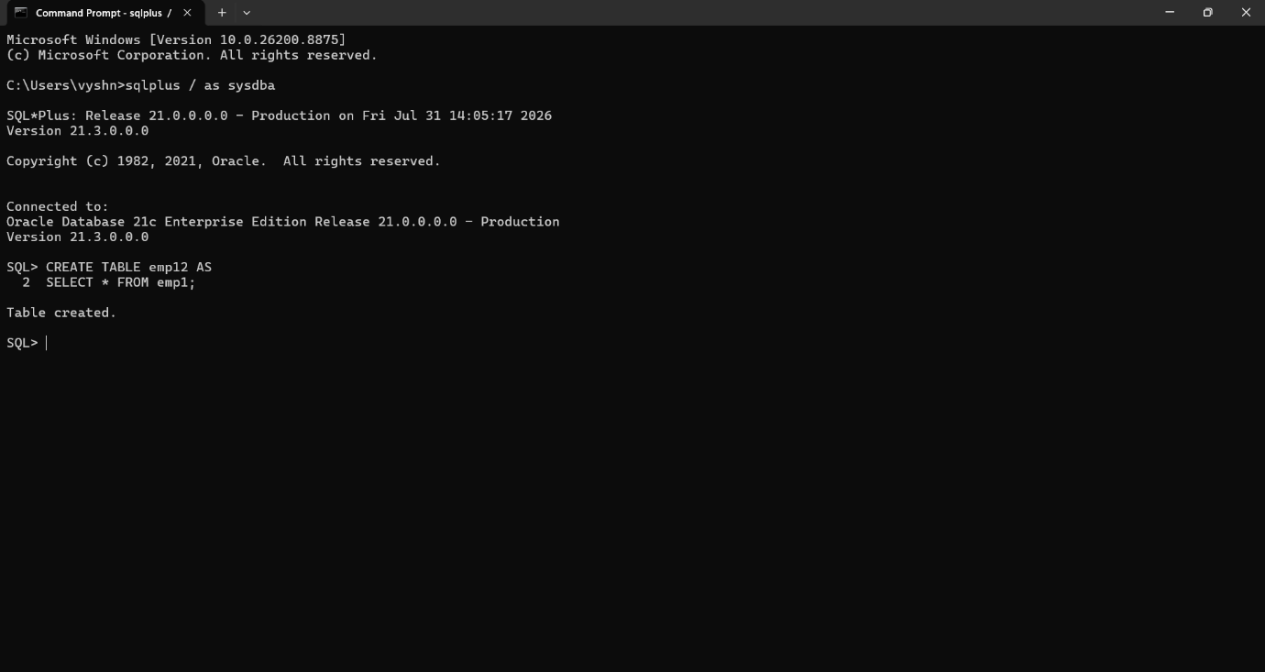

4.Add a new column Address-Varchar2(30) in the Emp1 table.
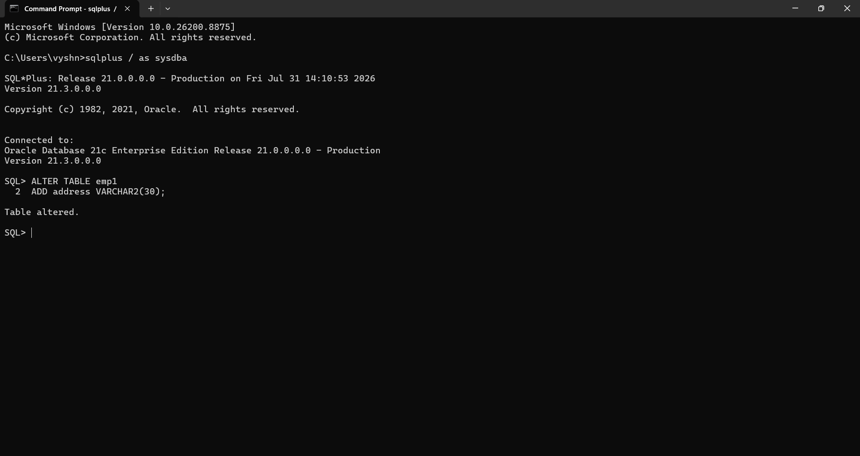
5.Rename SAL column in Emp1 table to SALARY
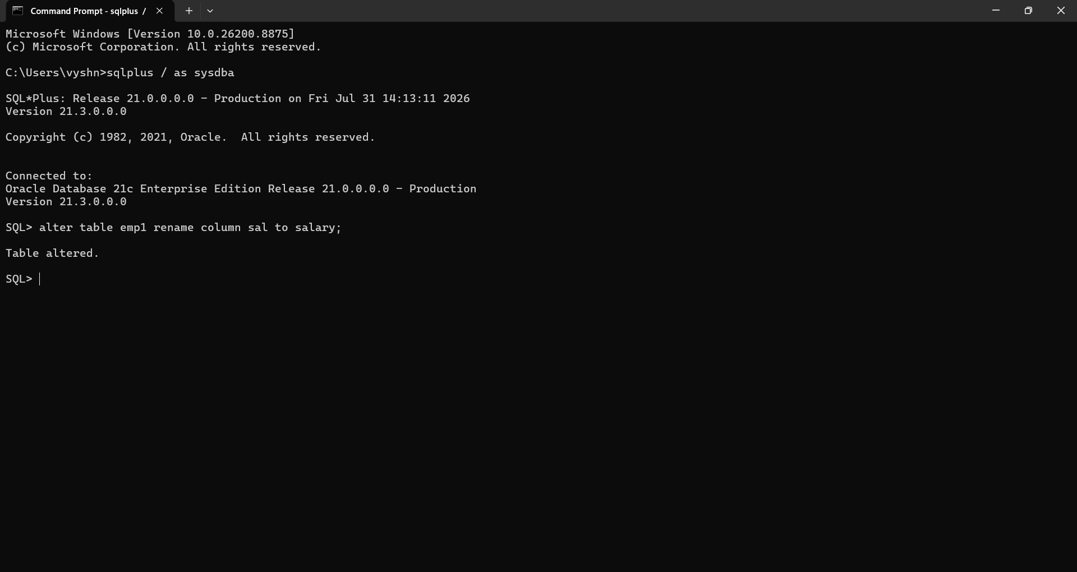

6.Rename the FK constraint names and verify the names for the Emp1
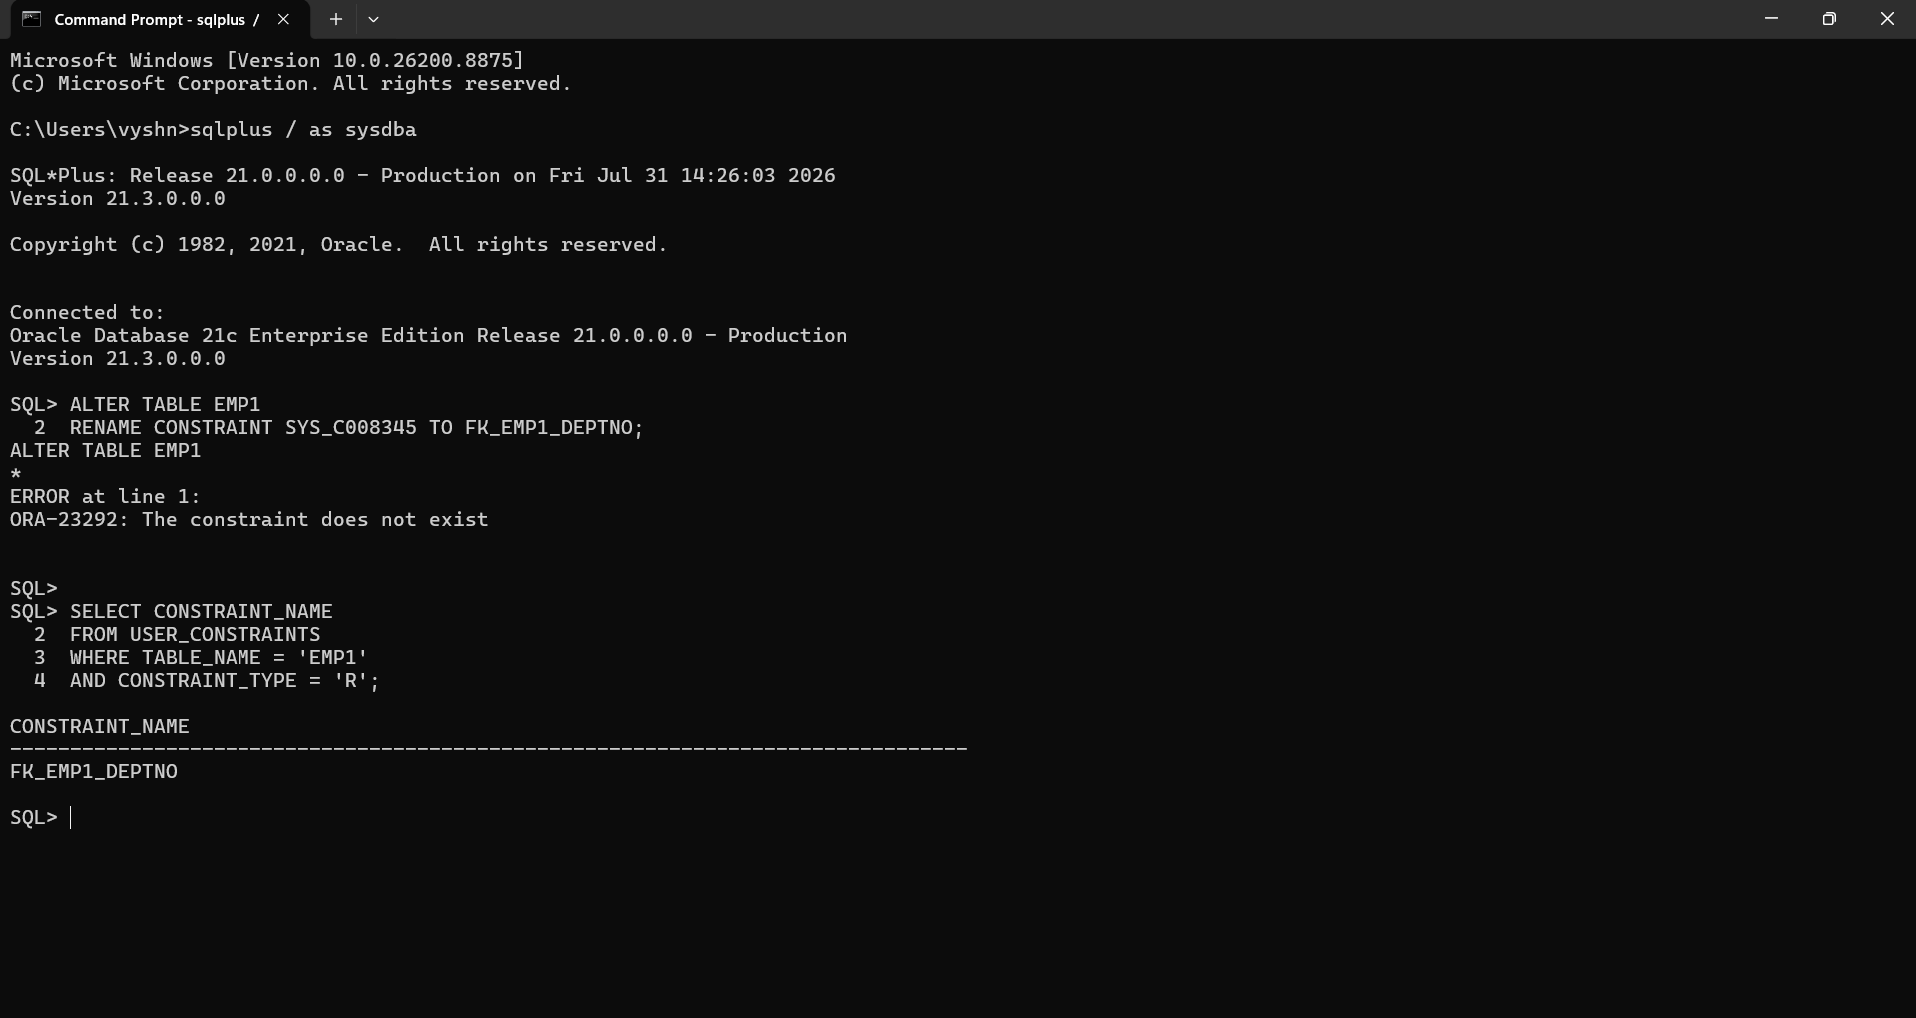
7.Modify ENAME Column by increasing the length of the column to 40.
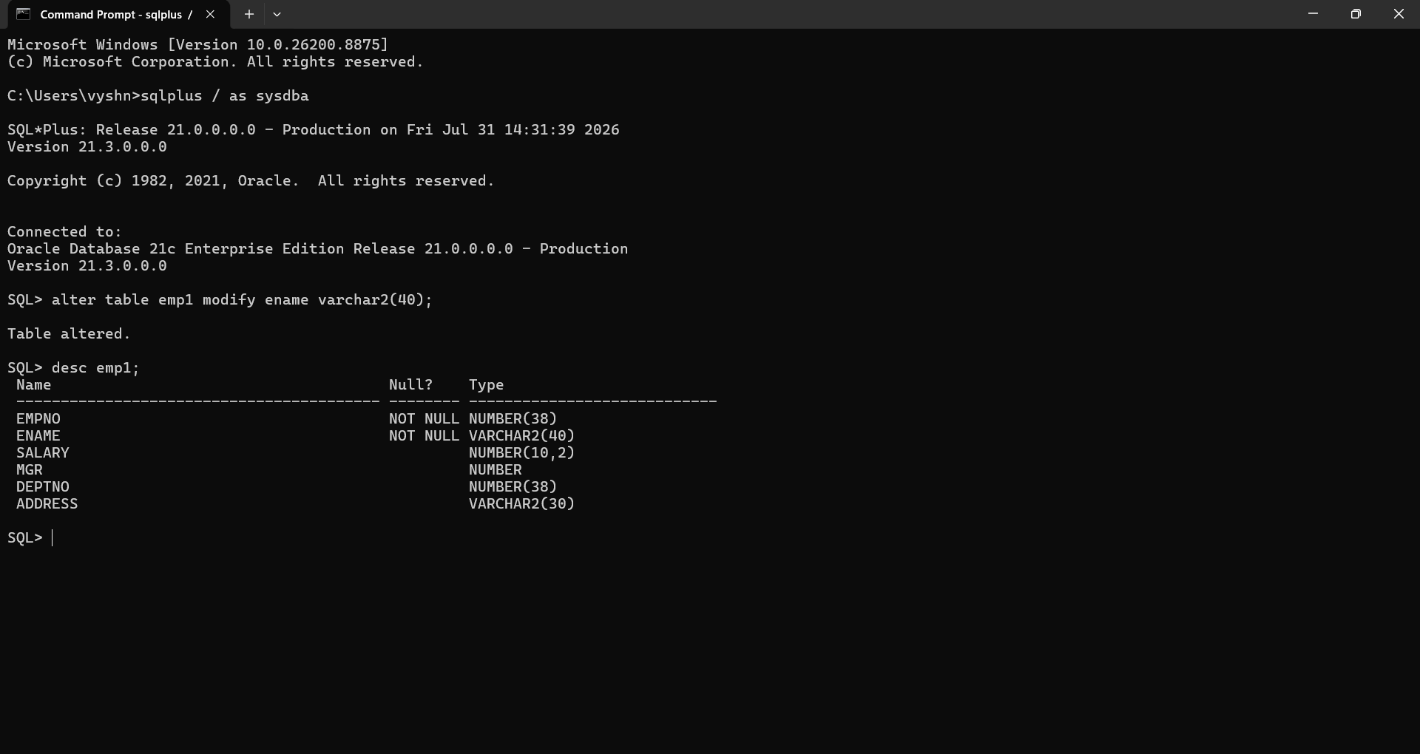

8.Drop the NOT NULL constraints for ENAME.
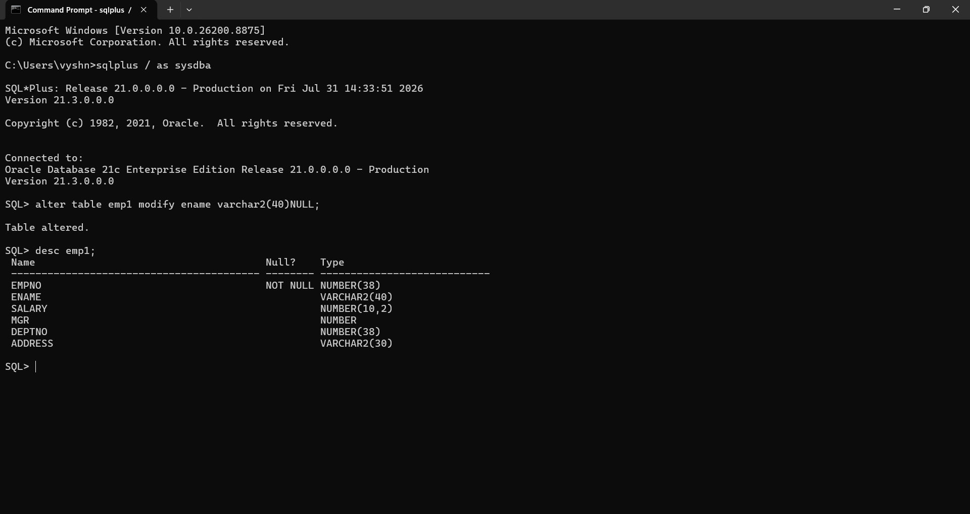
9.Create comment on Dept1 table as ‘Depts of WIPRO’
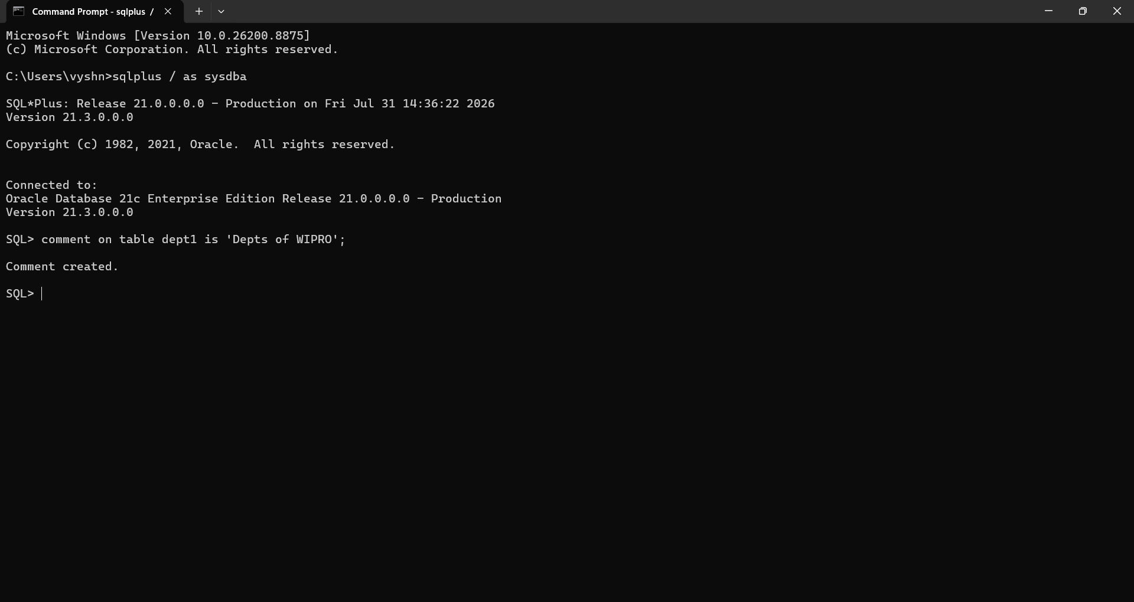

10.Create comment on Deptno of Dept1 as ‘Deptno of WIPRO’
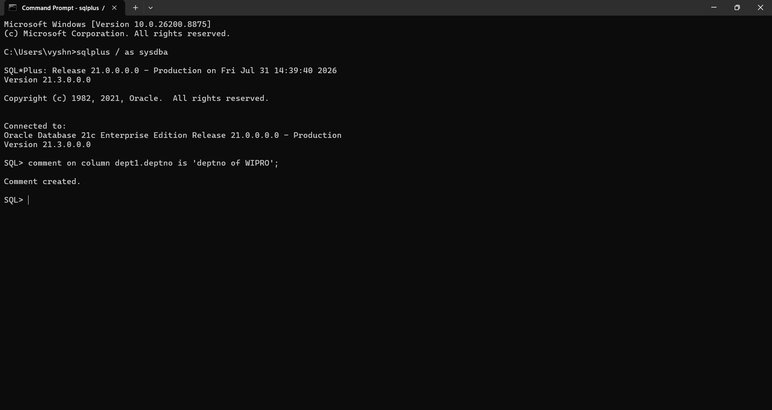
11.Create a comment on Emp1 table as ‘Employees of WIPRO’
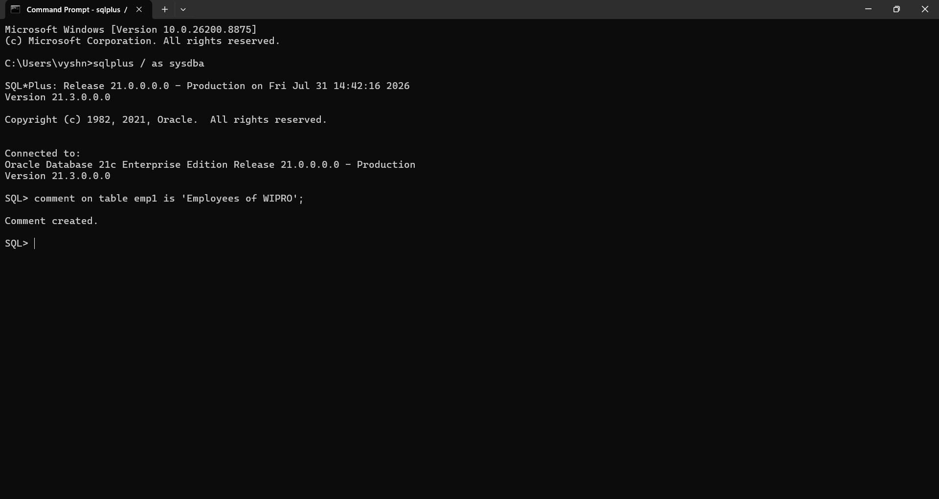

12.Create a comment on empno of emp1 table as ‘Empno of WIPRO’
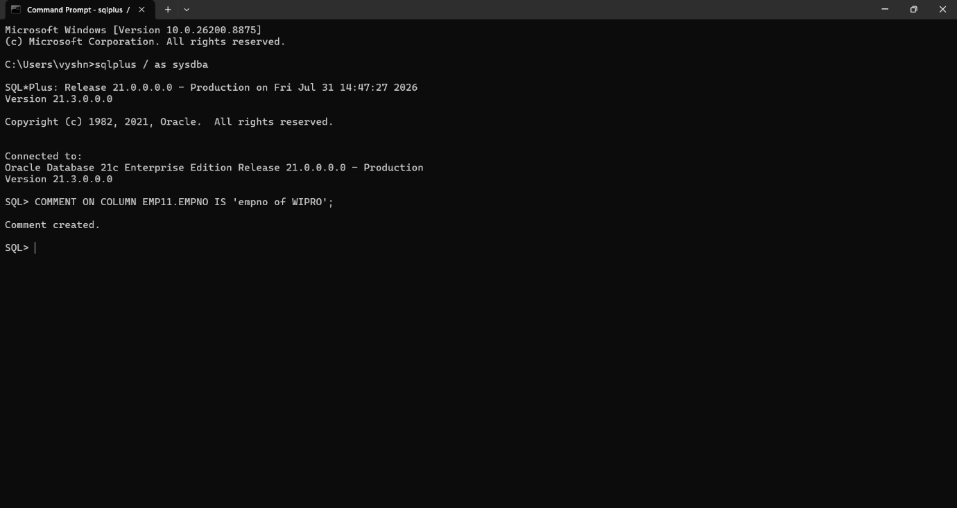
- Remove all the comment on the tables and column.
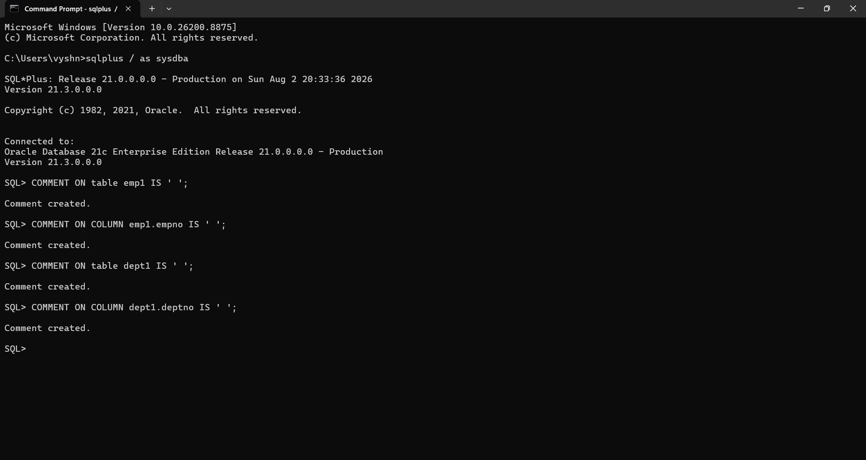

14.Set sal,ename,columns of Emp1 table as unused.
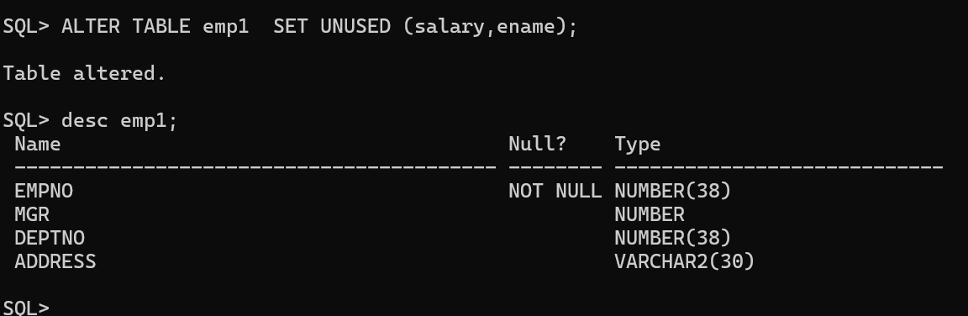
15.Drop Emp1,Dept1 Tables.
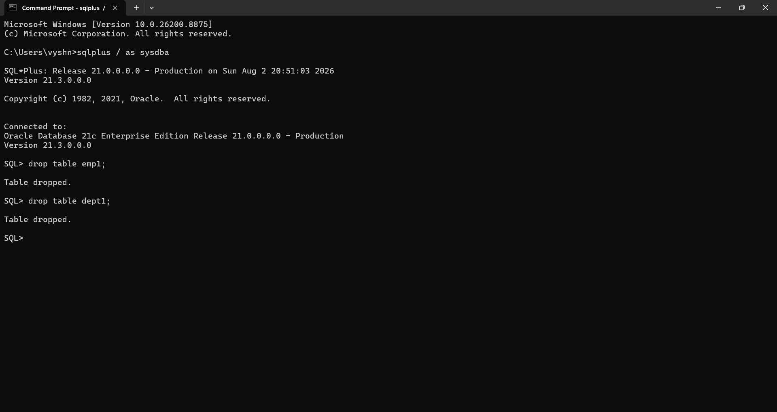

- Create Table Emp1 from Emp table by copying data also. Check your data.
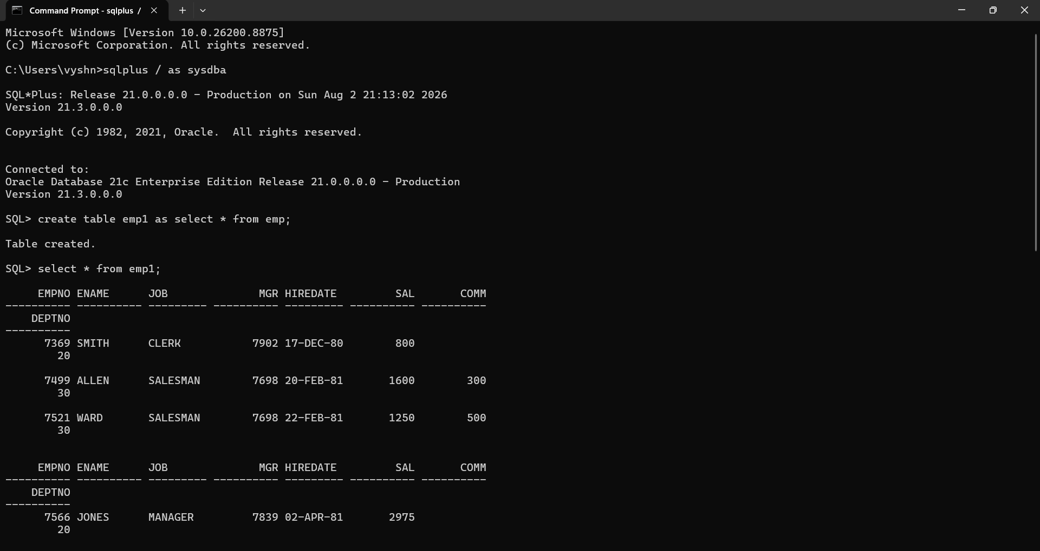
- Rename Emp1 to EMP_TEST.
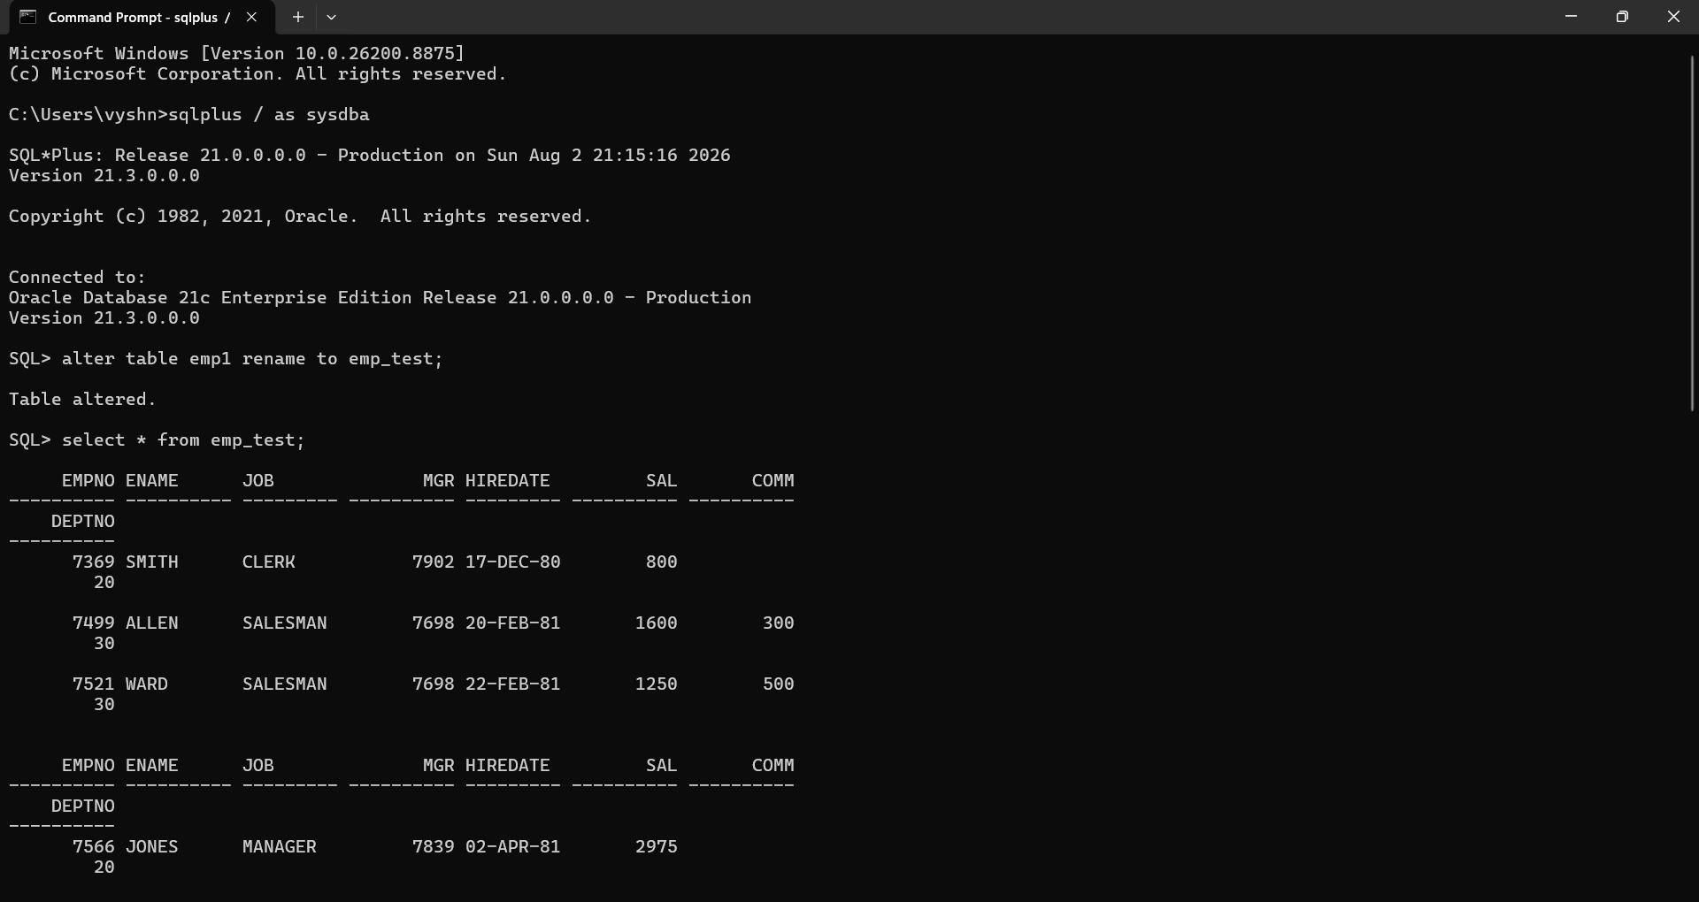

18.Truncate Emp_Test table and confirm your delete.
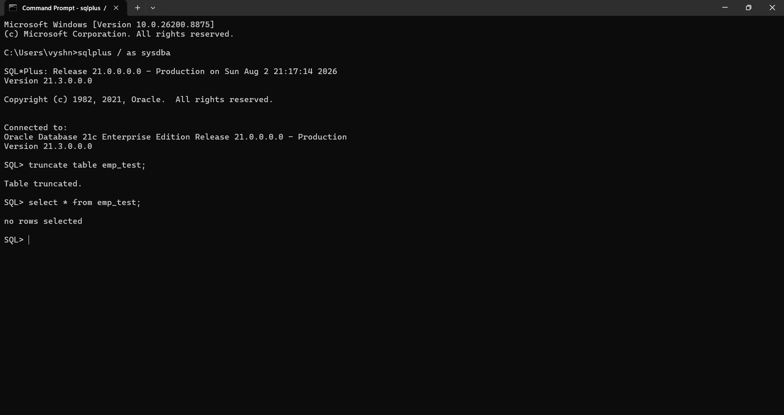
19.Create Emp2 from Emp by only copying Empno,Ename,sal column by coping Data.
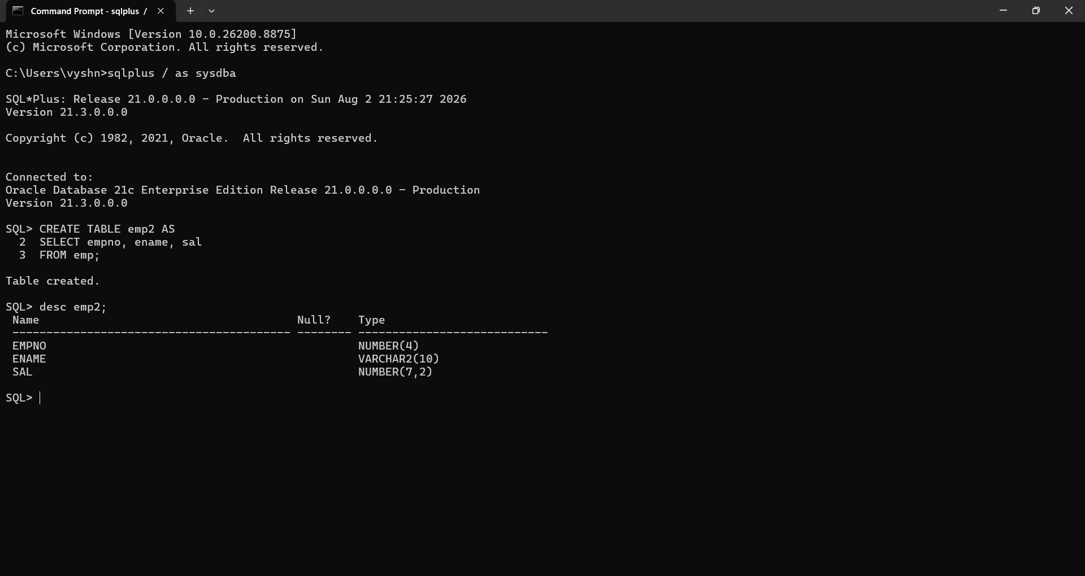

20.Drop Emp2 table.
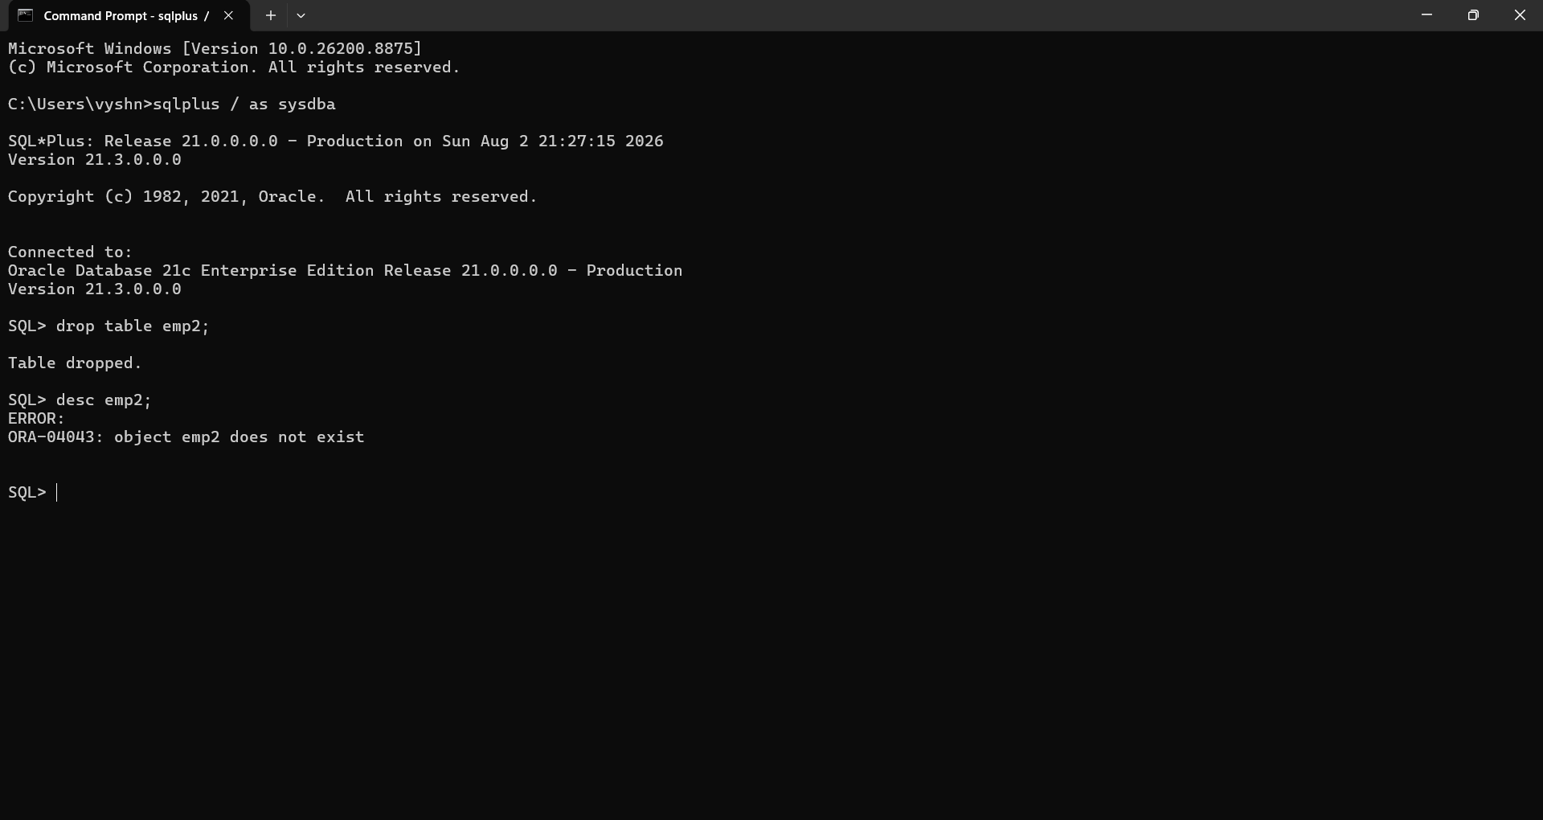
21.Create Emp2 table again from EMP table without copying data.

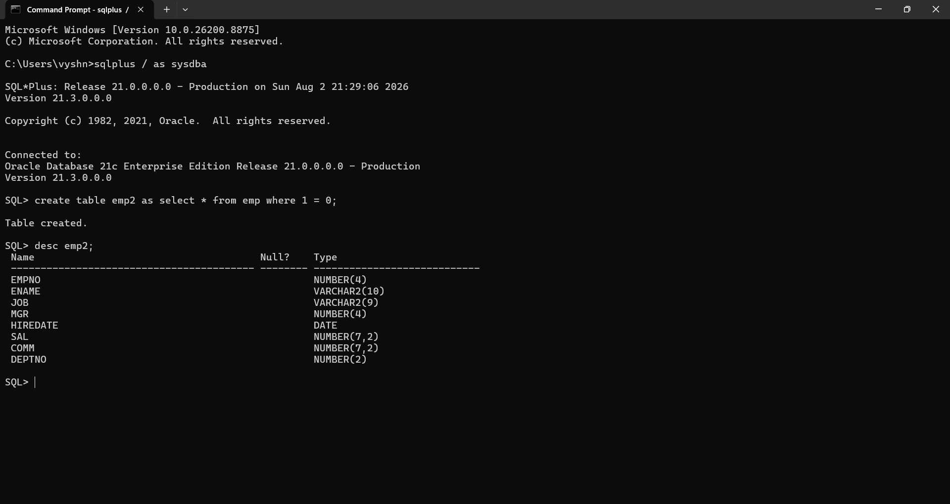

23.Drop Emp2 table.
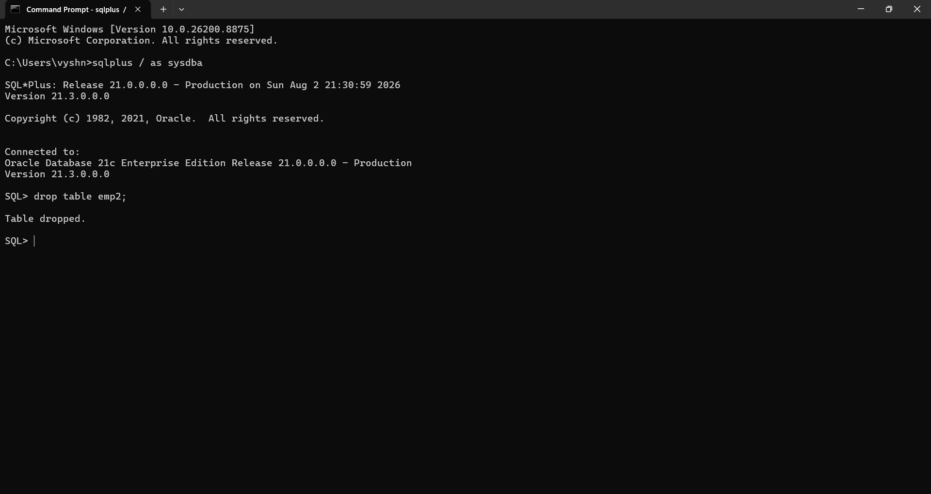
24.Flashback the first Emp2 table that contained data and check your table.
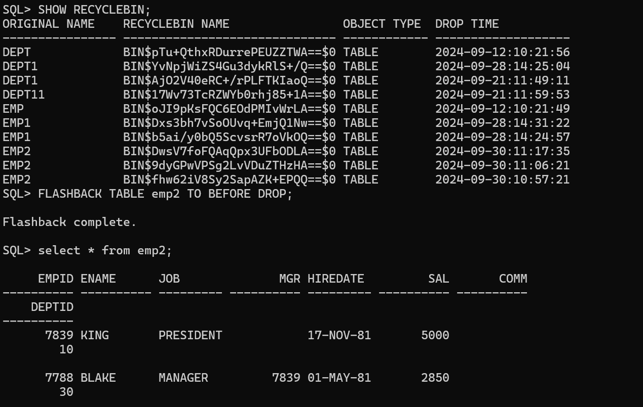

25.Flashback the recently dropped table by remaining to EMP2_1.
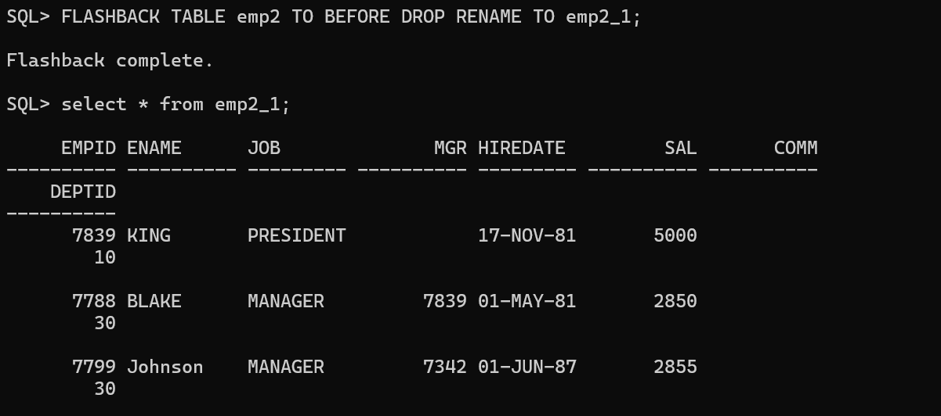
26.ccheck your table.
SQL> SELECT table_name FROM user_tables;

TABLE_NAME
------------------------------
REGIONS
LOCATIONS
DEPARTMENTS
JOBS
EMPLOYEES
JOB_HISTORY
DEPT
EMP
LODGE_DETAILS
SKILL_DETAILS
EMP_DETAILS

TABLE_NAME
------------------------------
EMP_SKILL
DEPT11
EMP11
STUDENT
SALGRADE
DEPT_1
EMP_1
PRODUCTSTB
DEPT1
EMP2_1
COUNTRIES

TABLE_NAME
------------------------------
EMP_TEST

23 rows selected.

